Seller and Inventory Management System.
Project Title: E-Commerce Order Management Database System

Project Title : E-Commerce Order Management Database System
Student Name : Thirupathi M
Register Number : C4S38023
Department : B.Sc Artificial Intelligence
Course : Artificial intelligence (AI)
Academic Year : 2024 – 2027

Seller and Inventory Management System

1. Create Seller Table
CREATE TABLE Seller (
SellerID INT PRIMARY KEY,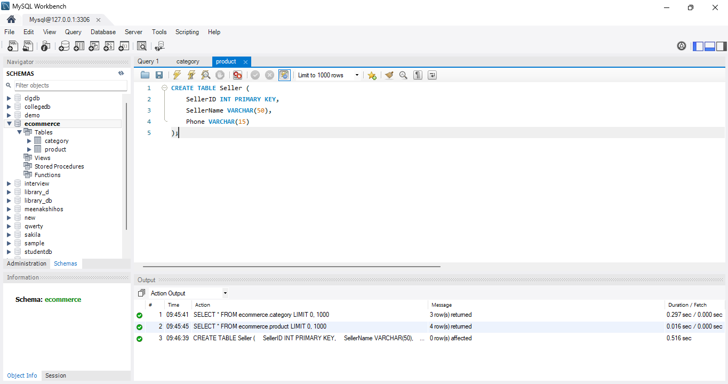
SellerName VARCHAR(50),
Phone VARCHAR(15)
);

2. Create Inventory Table
CREATE TABLE Inventory (
InventoryID INT PRIMARY KEY,
SellerID INT,
ProductID INT,
Stock INT,
FOREIGN KEY (SellerID) REFERENCES Seller(SellerID),
FOREIGN KEY (ProductID) REFERENCES Product(ProductID)
);

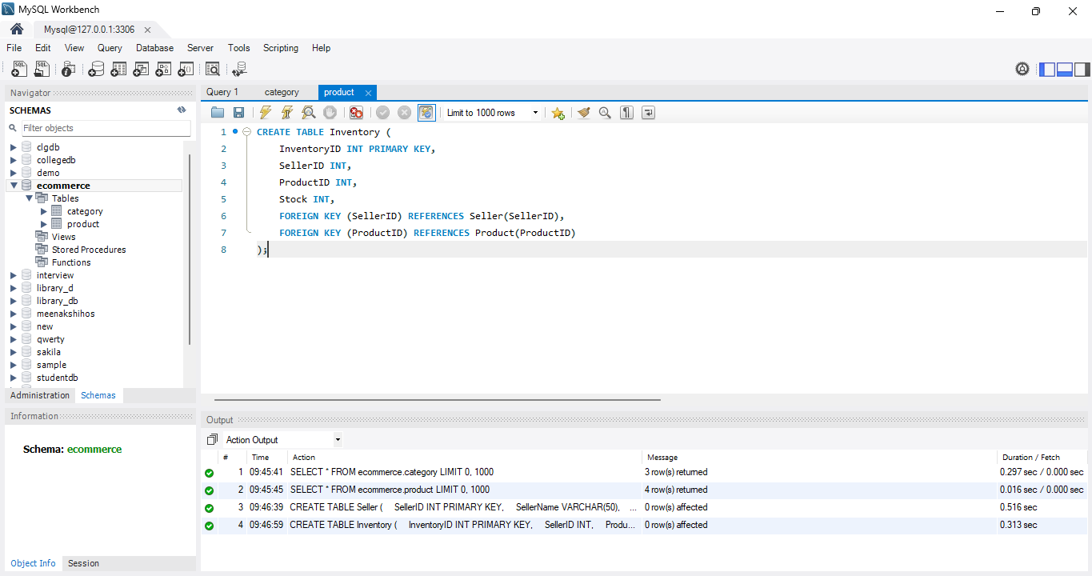

3. Insert Sellers
INSERT INTO Seller VALUES
(1, 'ABC Traders', '9876543210'),
(2, 'XYZ Store', '9876501234'),
(3, 'Online Mart', '9876512345');

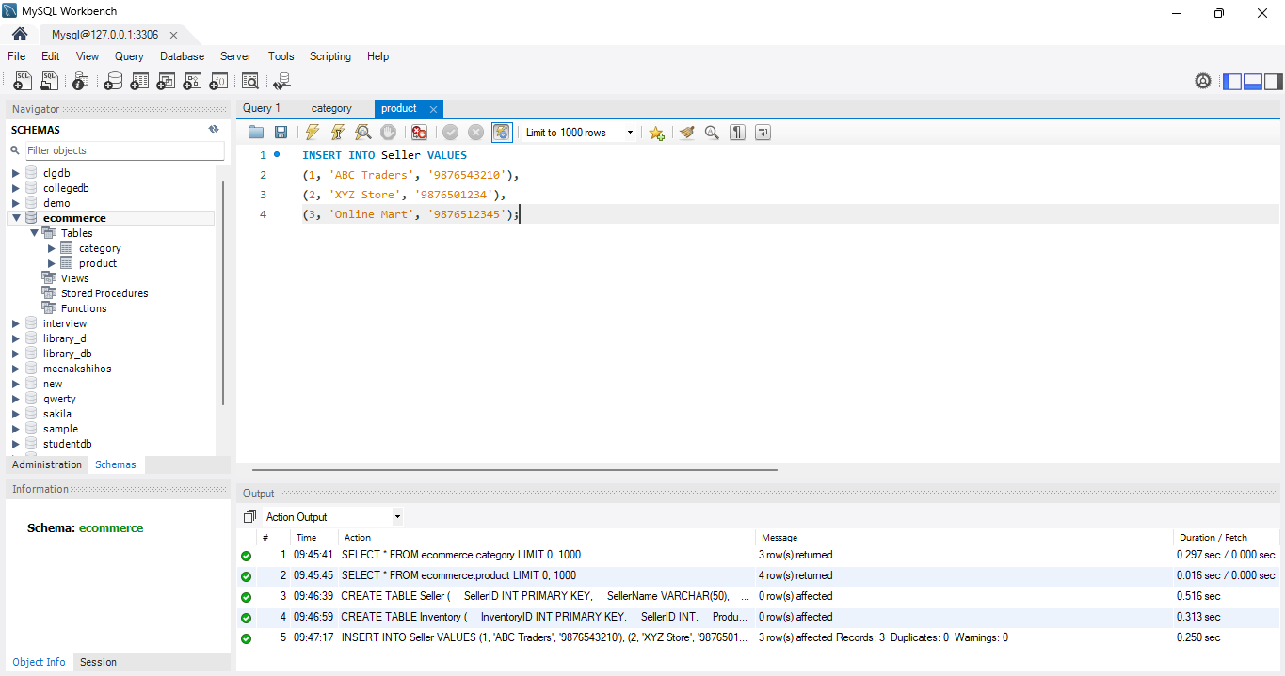

4. Insert Inventory
Remember that the ProductID must already exist in your Product table.
INSERT INTO Inventory VALUES
(1, 1, 101, 10),
(2, 1, 102, 20),
(3, 2, 103, 0),
(4, 3, 104, 30);

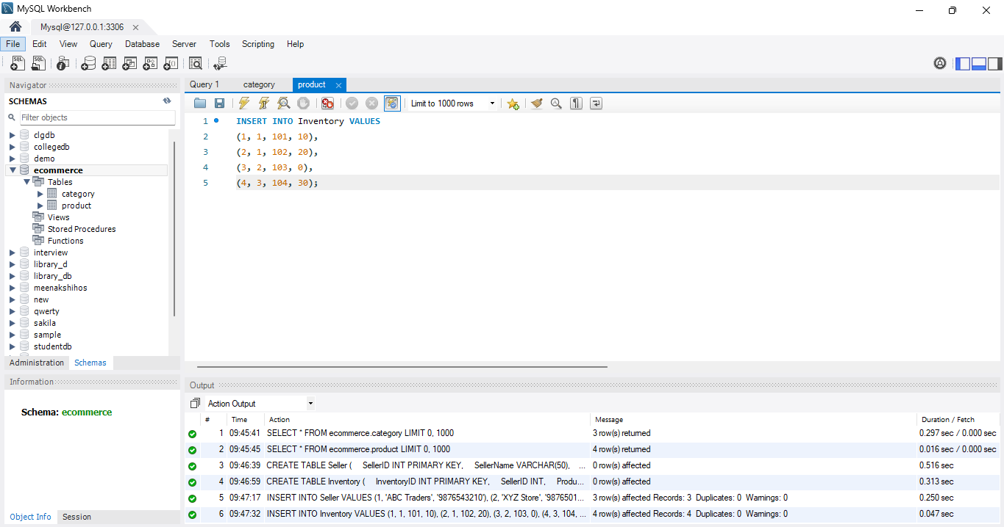

5. Display Seller Information
SELECT * FROM Seller;
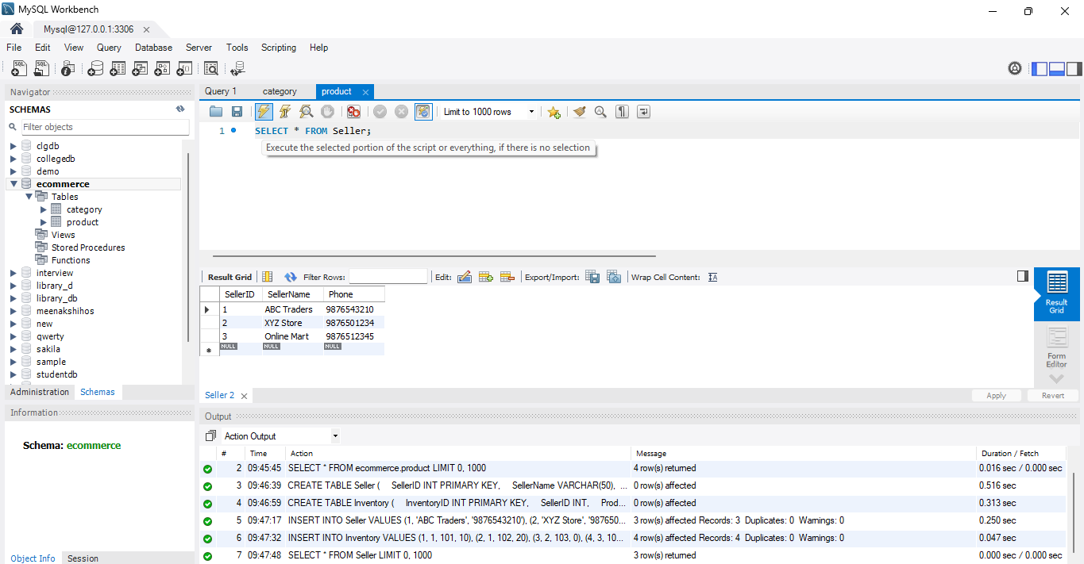

6. Display Inventory
SELECT * FROM Inventory;
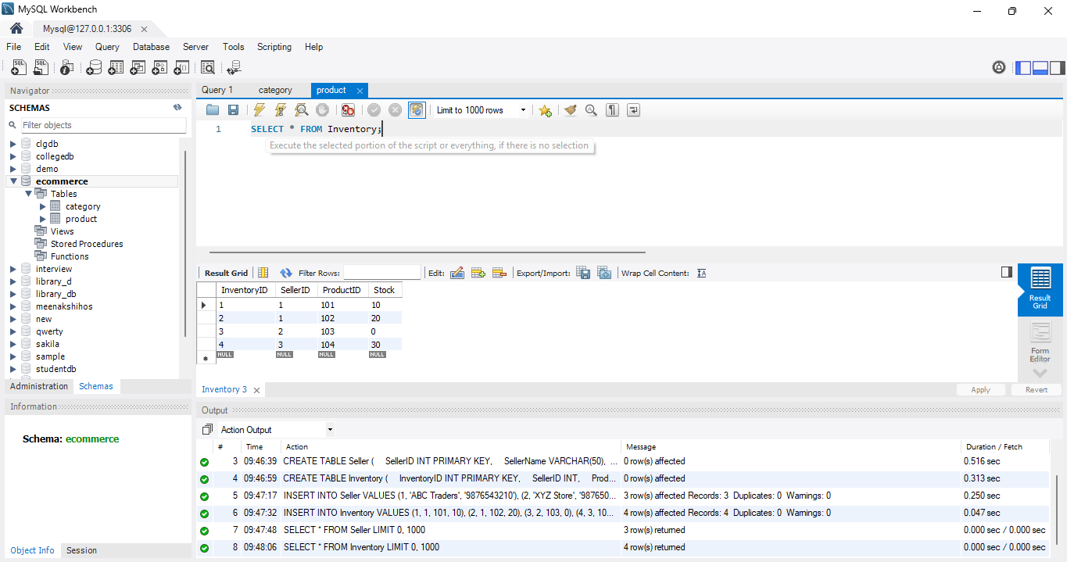
7. Update Stock
UPDATE Inventory
SET Stock = 15
WHERE ProductID = 101;
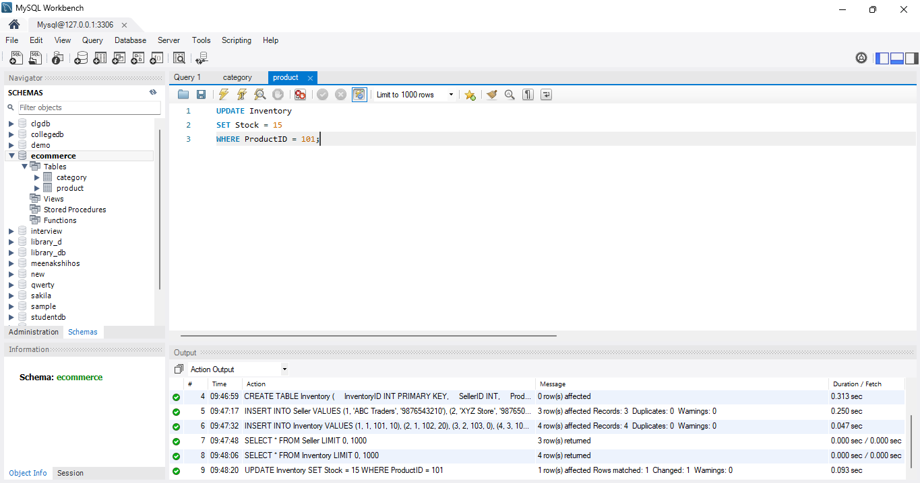
8. Track Available Products
SELECT * FROM Inventory
WHERE Stock > 0;
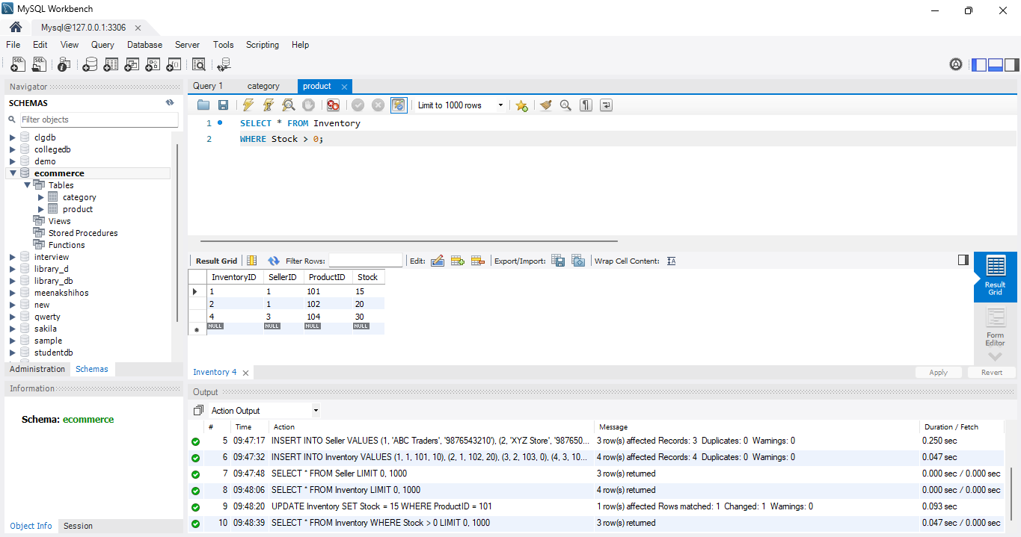

9. Track Unavailable Products

SELECT * FROM Inventory
WHERE Stock = 0;

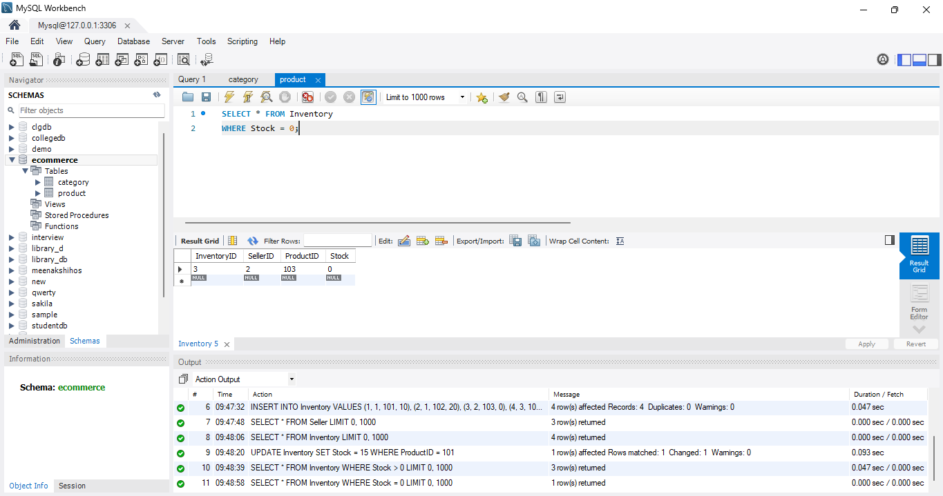

10. Inventory Status Report
SELECT
Product.ProductName,
Seller.SellerName,
Inventory.Stock
FROM Inventory
JOIN Product
ON Inventory.ProductID = Product.ProductID
JOIN Seller
ON Inventory.SellerID = Seller.SellerID;

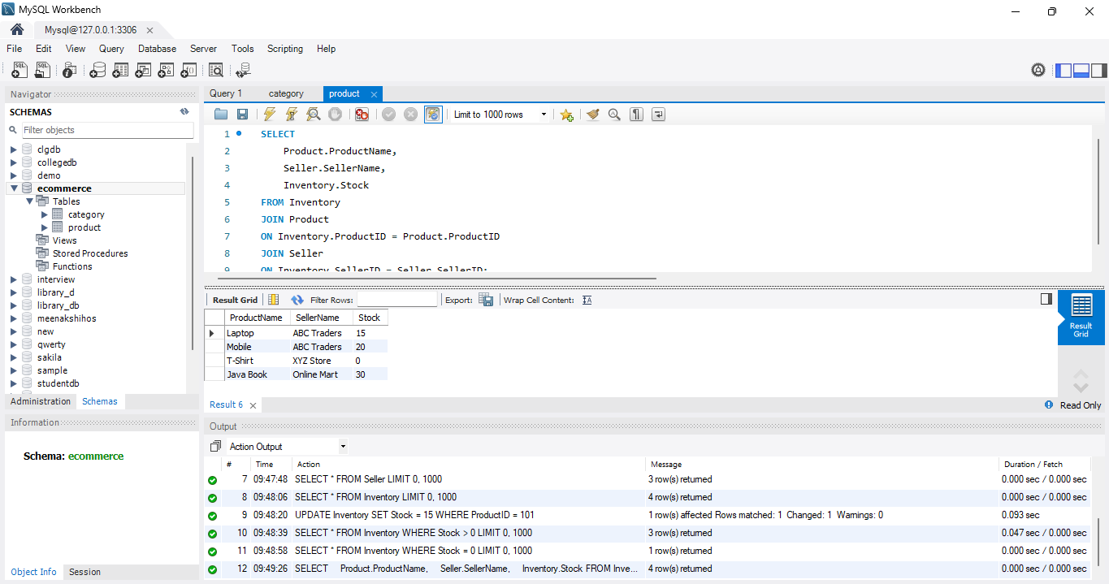

11. Show Available / Unavailable Status
SELECT
Product.ProductName,
Seller.SellerName,
Inventory.Stock,
CASE
WHEN Inventory.Stock > 0 THEN 'Available'
ELSE 'Unavailable'
END AS Status
FROM Inventory
JOIN Product
ON Inventory.ProductID = Product.ProductID
JOIN Seller
ON Inventory.SellerID = Seller.SellerID;

